Assignment 1 :
Suyash Damle
15CS10057

The question requires us to test the hypothesis that the rating is related to the year of release in different cases of the mean value being known and not known.

THE DATA:

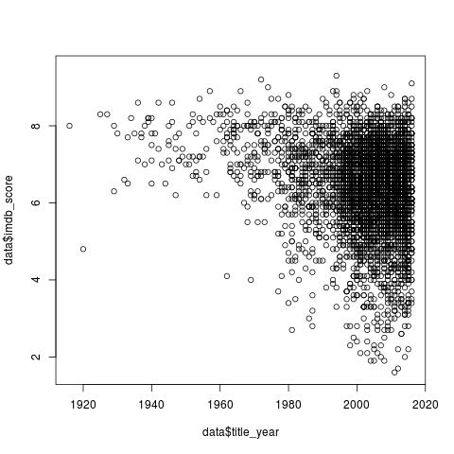

NULL HYPOTHESIS: That the two parameters are unrelated, ie, mu=x-bar

CASE 1:

Taking the mean upto 2015 as the population mean: x-bar= 6.417995
and, population standard deviation, sigma = 1.113393

Now, using the z-test for hypothesis testing, z-value= -1.208.
and Acceptance region: ( -1.959964 , 1.959964 )

Hence, H0 acceptable - no relation

CASE 2:

Now, no standard deviation is given. Hence, using the t-test for hypothesis testing:

Taking the s-value from the data post-2016: sample std deviation, s= 1.168841.
t-value= -1.207951

And, acceptance region: ( -1.960435 , 1.960435 ). Hence, H0 acceptable – no relation.

CODE OUTPUT:

Test statistic: z_value= -1.207951 . Acceptance region: ( -1.959964 , 1.959964 ) . Hence, H0 is ACCEPTABLE

Test statistic: t_value= -1.207951 acceptance region: ( -1.960435 , 1.960435 ) . Hence, H0 is ACCEPTABLE

Hence, the initial given hypothesis to be tested is false

